**Hotel Booking Management System**

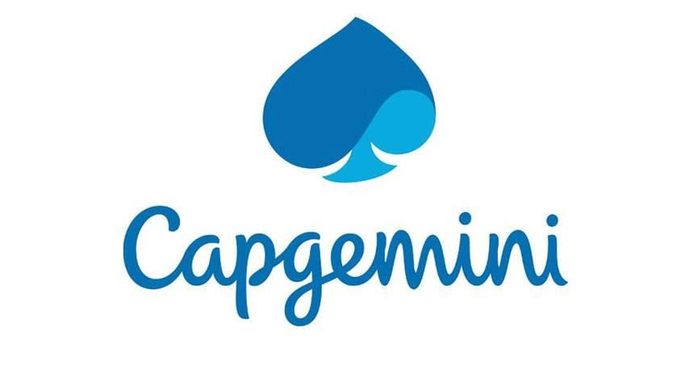

|  |
| --- |
| Team |
| Mohit Murotiya(Scrum Master) |
| Abhinav Deshpande |
| Shankar Linganvad |

**Team Members:**

Table of Contents

1. Introduction ------------------------------------------------------------------------------------
2. Overview ----------------------------------------------------------------------------------------
3. Epic & Stories ----------------------------------------------------------------------------------
4. Use Cases & Class Diagrams ----------------------------------------------------------------
   * 1. Hotel Management System
5. Add Hotel
6. Update Hotel
7. Delete Hotel
   * 1. Room Management System
8. Add Room
9. Update Room
10. Delete Room
    * 1. User Management System
11. User Register into the system
12. User Login to the system using his/her credentials
13. User Logout
    * 1. Admin Report Management System
14. View List of Hotels
15. View Bookings of specific hotel
16. View guest list of specific hotels
17. View bookings for specified date
    * 1. Booking Management System
18. Search for hotel rooms.
19. Book hotel rooms.
20. View Booking Status
21. System Requirements

1. Introduction

This project is aimed at developing an online Hotel Bookings Management System (HBMS). This is a web-based application that can be accessed over the web. This system can be used to search for Hotel rooms and reserve them. This is an integrated system that contains both the user component, Hotel-Employee component and the Admin component. There are features like report generators etc in this system.

2. Overview

Hotel Booking Management System has the following functional requirements:

* Admin

1. Login to the system using his/her credentials
2. Perform Hotel Management (add/delete/modify Hotel info like description, any special offers etc.
3. Perform Room Management (add/delete/modify Room info like revised tariff)
4. Generate Reports like:
5. View List of Hotels
6. View Bookings of specific hotel
7. View guest list of specific hotels
8. View bookings for specified date

* Customer and Hotel-Employee

1. Register into the system.
2. Login to the system using his/her credentials.
3. Search for hotel rooms.
4. Book hotel rooms.
5. View Booking Status

The model followed was an agile model. Agile SDLC model is a combination of iterative and incremental process models with focus on process adaptability and customer satisfaction by rapid delivery of working software product. Agile Methods break the product into small incremental builds. These builds are provided in iterations.

The project had one sprint to undergo. Spring Framework was introduced to us with Rest implementation incorporated into spring because of its feasibility. Spring converted to Spring Boot into individual microservices along with Logger implementation. Each microservice gives call to another microservice as per the functionality is required. The entire user interface with Microservices and JPA was implemented. The H2/MySQL database was used as the data source. The UI is implemented in Angular and herein the entire application is ready to serve a Hotel Booking Management System.

3. Epic & Stories

|  |  |  |  |  |
| --- | --- | --- | --- | --- |
| Epic | Stories | As a/an | I want to | So that .. |
| Hotel Management System | Add a Hotel | Admin | Enter the Hotel details and Image | A new Hotel is added to the Hotel database |
| Update a Hotel | Admin | Change the details entered for the Hotel | To update the Hotel details or to change the number of rooms in the hotel |
| Delete a Hotel | Admin | To delete a hotel | Hotel will be soft deleted from the Hotel database |

|  |  |  |  |  |
| --- | --- | --- | --- | --- |
| Epic | Stories | As a/an | I want to | So that .. |
| Room Management System | Add a Room | Admin | Enter the Room details and Image | A new Room is added to the Hotel database |
| Update a Room | Admin | Change the details entered for the Room | To update the Room details or to change the number of types of rooms. |
| Delete a Room | Admin | Delete a room | Room will be soft deleted from the Hotel database |

|  |  |  |  |  |
| --- | --- | --- | --- | --- |
| Epic | Stories | As a/an | I want to | So that .. |
| User Management System | User Registration | User | Successfully Register a  new User | A New User is added to GO |
| User Login  User Logout | User  User | Login already registered user  Logout a user who is already logged-in | User is Logged-in to use his functionalities  User is successfully logged-out |

|  |  |  |  |  |
| --- | --- | --- | --- | --- |
| Epic | Stories | As a/an | I want to | So that .. |
| Admin Reports Management System | View List of Hotels | Admin | View the list of all Hotels | Admin can analyse the details of all hotels |
| View Bookings of Specific Hotel | Admin | View Bookings of specific hotel | Admin can analyse the growth in the bookings of that specific hotel |
| View Guest list of Specific Hotel | Admin | View Guest list of specific hotels | Admin can analyse and keep the record of the Guests in that specific hotel |
| View Bookings for Specific date | Admin | View Bookings done between specific dates | Admin can analyse and keep the record of the bookings. |

|  |  |  |  |  |
| --- | --- | --- | --- | --- |
| Epic | Stories | As a/an | I want to | So that .. |
| Booking Management System | Search for Hotel rooms | Customer/Employee | To search a Hotel by name or rating or city | Easy to find a hotel from the entire list |
| Book Hotel Room | Customer/Employee | To book a room by room type | I can stay in the hotel till my specified time period |
| View Booking Status | Customer/Employee | To get the report of the booking status | I can ensure my booking for specific number of days |

4. Use Cases

4.1 Hotel Management System

Overview

Hotel is one of the most important aspects of any Hotel Booking website. Our main aim is to make a user-friendly Hotel management system where operations can be performed with one click. We tried to improvise the update option in such a way that the update form will be prefilled with the data of the hotel such that the admin has to only update the field admin wants. Hotel Management System can only be accessed with proper credentials of an Admin.

Prerequisite

User must be logged in as Admin to perform the add Hotel, update Hotel and delete Hotel functionalities.

Use Case Diagram for Hotel Management System

Class Diagram for Hotel Management System

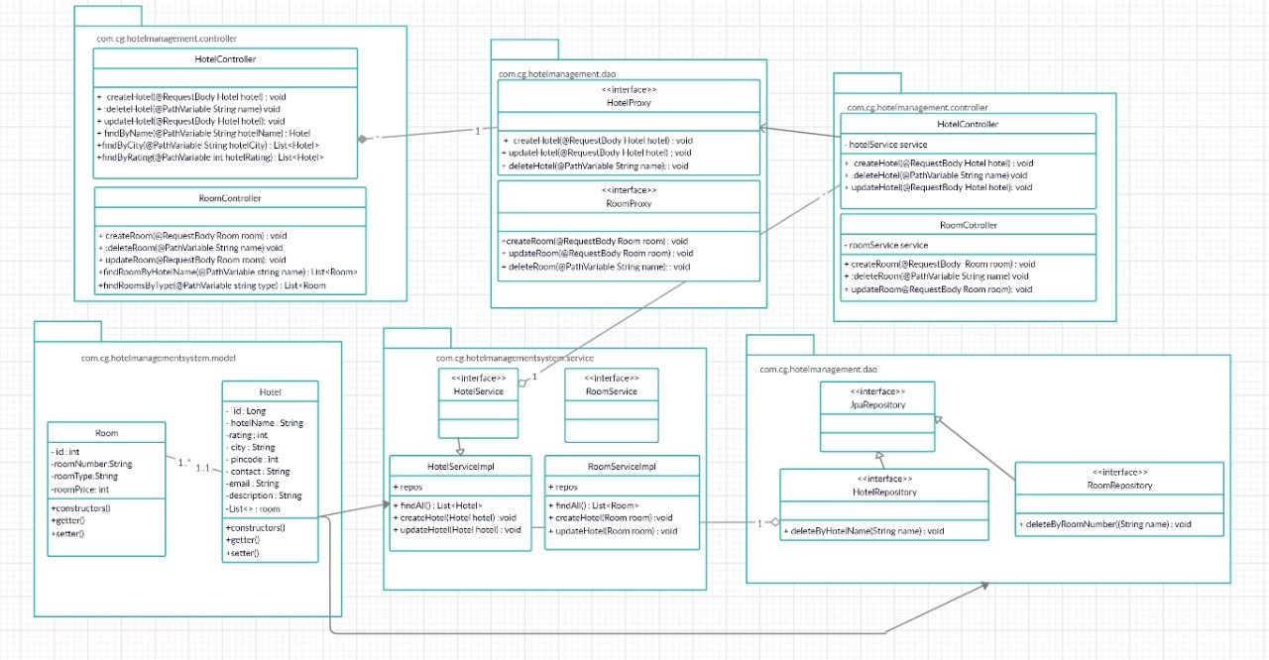

1. Add a Hotel

This module has been designed to add a hotel in the database. This can be only accessed by Admin. The form should be designed with proper validation with all fields arerequired.

* 1. Update a Hotel

It has been observed that during manual entry for a Hotel any individual can often make mistakes in entering data. Hence there should always be a scope to update the data which has been once entered. Thus, it is our admin’s requirement to introduce an update option. Hence, we have implemented a user-friendly update option for our Hotel management system. Just on clicking an update button over a particular hotel the update form will appear. Now we gather from admin review that if they have to refill the entire hotel form then there might be a chance of making more mistakes. It may happen that on correcting a particular data user have entered some wrong data for other fields. Hence our software is designed in such a way that on clicking the update option, the form will be already prefilled with data. Admin has to only make changes where it requires. Moreover, we have been restricted to make any further changes in the Hotel ID field otherwise it will be treated as a completely new Hotel.

* 1. Delete a Hotel

Admin needs to click a button to delete a Hotel. A confirmation warning will pop up. On clicking on the confirm message the hotel will be deleted.

4.2 Room Management System

Overview

Room is another important aspect of any Hotel Booking website. Our main aim is to make a user-friendly Room management system where operations can be performed with one click. We tried to improvise the update option in such a way that the update form will be prefilledwith the data of the room such that the admin has to only update the field admin wants.Room Management System can only be accessed with proper credentials of an Admin.

Prerequisite

User must be logged in as Admin to perform the add Room, update Room and delete Room functionalities. The Hotel must be present so that these functionalities of Room management system can be used.

Use Case Diagram for Product Management System

1. Add a Room

This module has been designed to add a room in the database. This can be only accessed by Admin. The form should be designed with proper validation with all fields arerequired.

1. Update a Room

It has been observed that during manual entry for a Room any individual can often make mistakes in entering data. Hence there should always be a scope to update the data which has been once entered. Thus, it is our admin’s requirement to introduce an update option. Hence, we have implemented a user-friendly update option for our Room management system. Just on clicking an updatebutton over a particular room the update form will appear. Now we gather from admin review that if they have to refill the entire room form then there might be a chance of making more mistakes. It may happen that on correcting a particular data user have entered some wrong data for other fields. Hence our software is designed in such a way that on clicking the update option, the form will be already prefilled with data. Admin has to only make changes where it requires. Moreover, we have been restricted to make any further changes in the Room ID field otherwise it will be treated as a completely new Room.

1. Delete a Hotel

Admin needs to click a button to delete a Room. A confirmation warning will pop up. On clicking on the confirm message the room will be deleted.

4.3 User Management System

Overview

User management is one of the main aspects for any application. Registering a new user, Logging-In as different roles of user and Logging-out comes under this system. Our Software is made highly secured using authentication guard of angular. Also, Authorization is used to ensure that different types of users can access different types of functionality i.e. Role Mapping.

1. User Registration

Registration functionality is for user to register as New User to the User database. Only Customers and Employees can register directly from this functionality. We have to select the user category in the drop-down menu from where it will be mapped to different category roles. We have also designed a user-friendly registration form with several validations.

**Username:** Should be unique, no other user in the User database must have used the same username.

**Password:** Should contains at least one small letter, one capital letter, one digit, one special character like @, #, ! and must be at least 8 characters long.

**Re-enter Password:** Should match with the previous password to prevent any mistype.

**Phone Number and email:** email should be in proper email format and phone number must be 10 digits long.

*\*All fields are required.*

1. User Login

This module has been designed to Log-In an existing user. Any type of user can Log-in from this functionality. The form is designed with proper validation.

***Validation***:

**Password:** Should contains at least one small letter, one capital letter, one digit, one special character like @, #, ! and must be at least 8 characters long.

*\*All fields are required.*

1. User Logout

This module has been designed to Log-Out an already logged-in user.

***Pre-Requisite***:

User should already be logged-in.

Use Case Diagram for User Management System

Class Diagram for User Management System

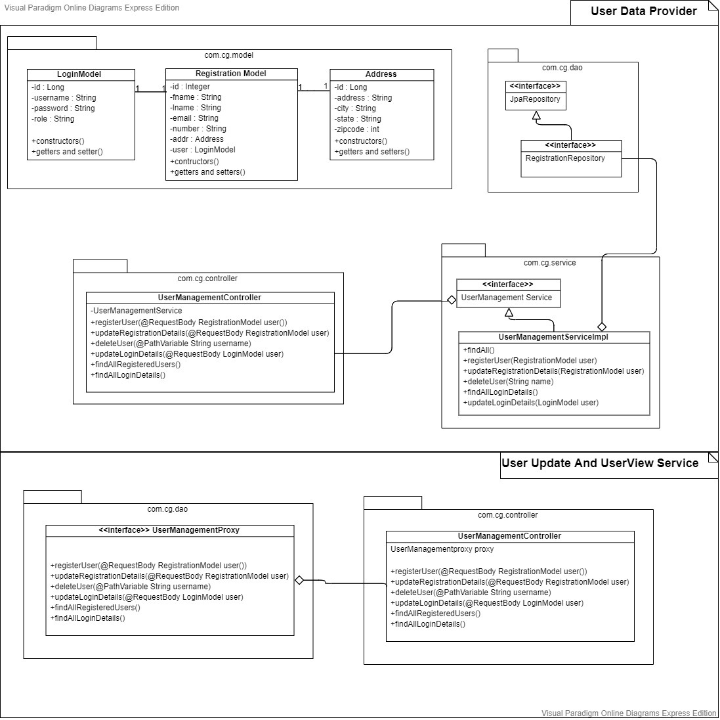

4.4 Admin Reports Management System

Overview

Reports of a company are the main tool for tracking and analysing performance and overall business health. A well-documented report will reveal nuances related to core business functions, while opening opportunities to improve and make market gains. In this module we are presenting reports such as list of hotels, Bookings of specific Hotel, Guest List of specific Hotel. We are also providing the list of bookings done within a particular duration of time. We have also provided search, sort and pagination for every generated tables.

Prerequisite

User must be logged in as Admin to get the following reports.

Use Case Diagram for Admin Reports Management System

1. View List of Hotels

This function is used by admin to view list of all the hotels and its details.

1. View Booking of Specific Hotel

This function is used by admin to view booking details of specific hotel.

1. View Guests list of Specific Hotel

This function is used by admin to view guests list of specific hotels.

1. View Bookings for specific Date

This function is used by admin to view bookings between specific dates.

* 1. Booking Management System

Overview

In an hotel booking site, a customer chooses ahotel to stay for. For that, he needs to book the room. So, booking plays a very important role for booking a room in hotel booking sites. We have tried to make the process of booking an easier one so that the customer doesn’t find any difficulties or complexities in booking the room. The room will be booked only when the credential of the customer is correct.

Prerequisite

User must be logged in as Admin to get the following reports.

1. Search for Hotel Rooms

This function is used by customer to search the hotel. We have given the dropdown to select the options based on search by name, city, rating of the hotels.

1. Book Hotel Rooms

This function is used by customer or hotel-employee to book the rooms for themselves or for guests respectively. The Booking of rooms will be done by considering various room types available in the hotel.

1. View Booking Status

This function is used by customer or hotel-employee to view their booking status or customers’ booking status respectively.

Use Case Diagram for Booking Management System

Class Diagram for Booking Management System

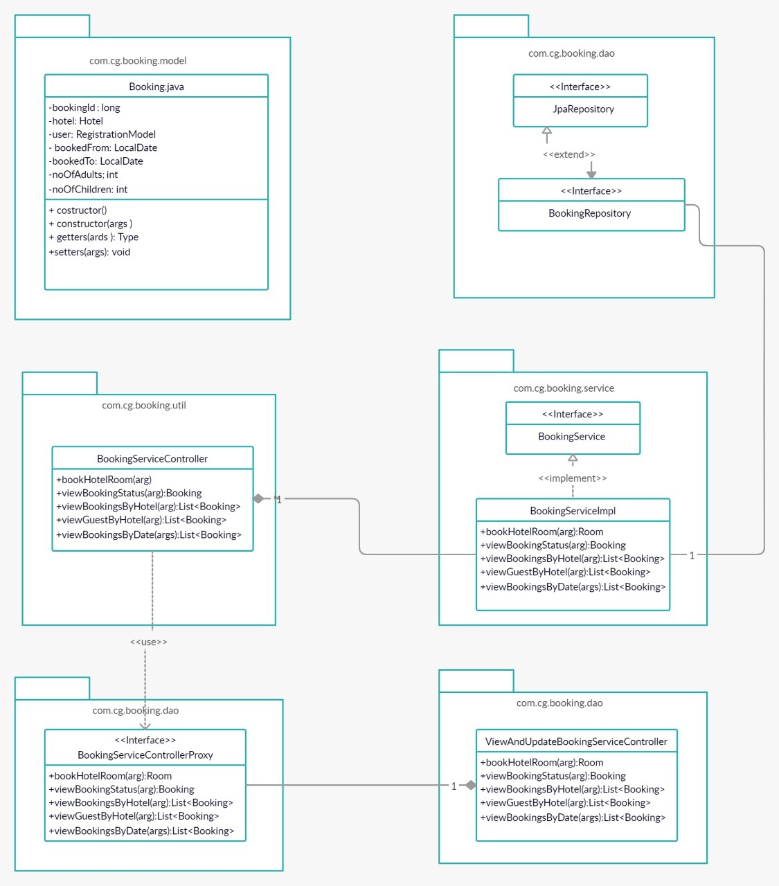

5. System Requirements

Below is a list of the minimum Hardware and Software requirements to access CheapStays website.

**Operating System:**

* Windows 7 and above.
* Mac OSX 10.8, 10.9, 10.10 or 10.11
* Android 3 and onwards.

**Hardware:**

* Processor (CPU) with 2 gigahertz (GHz) frequency or above
* A minimum of 4 GB of RAM
* Monitor Resolution 1024 X 768 or higher (For better view)
* A minimum of 5 GB of available space on the hard disk
* Internet Connection Broadband (high-speed) Internet connection with a speed of 2 Mbps or higher
* Keyboard and a Mouse or some other compatible pointing device

**Browsers:**

* Chrome* 58+
* Microsoft Edge* 20+
* Mozilla Firefox 40+
* Internet Explorer 11+ (Windows only)
* Safari 6+ (MacOS only)
* Android* 3+

*\**Google Chrome version 42+ and Microsoft Edge do not support NPAPI-type plug-ins, including Java plug-ins and many media browser plug-in.

*Users using unsupported browsers may experience issues submitting forms, placing orders, purchasing, updating details and transaction management threads.*

**Browser Configuration:**

Your browser must be configured as follows:

* **Strongly Recommended--**add [www.CheapStays.com](http://www.CheapStays.com)to trusted sites.
* JavaScript must be enabled
* CORS must be configured properly
* Cookies must be enabled.
* Pop-up windows must be enabled.

**Software:**

* Java — to view and interact with all available blackboard applications.
* Spring Tool Suite — STS workbench was used to run JDK (write, compile and run the code).
* Visual Studio Code — for writing codes for frontend using Angular, VS Code was used as a workbench.
* Apache Tomcat — it was used as a server for hosting the website.